**File Transfer between SFTP and Windows Server**

Contents

**Summary** 1

**Features** 1

**Design**: 2

**Config.Json** 2

**TFS Path Code Path:** 3

**Build, Deploy and Configure:** 3

**Schedule to run at regular interval:** 3

## **Summary**

SFTPFileTransfer.exe is a windows console application and configurable to support file transfer between SFTP and Windows Server directories. SFTPFileTransfer is a .net application and uses WinSCP.exe process and libraries to transfer files between SFTP and Windows servers.

## **Features**

1. File Transfer between any SFTP/SSH and Windows Server
2. When transfer if the same file name already exist on the destination, the copied File Name will be renamed in “SourceFileName-hh-mm-ss-ms” format to avoid file overwrite
3. Integrated with Log4Net
4. Inbound and outbound files are transferred in-parallel
5. It can be scaled out (i.e., duplicate deployment shall be done)
6. It’s a console program, so it shall be scheduled with Windows Task Scheduler to run in different interval.
7. In-progress files ended with “.filepart” on SFTP will not be downloaded while transferring. This is to avoid partial file download.

## **Design**:

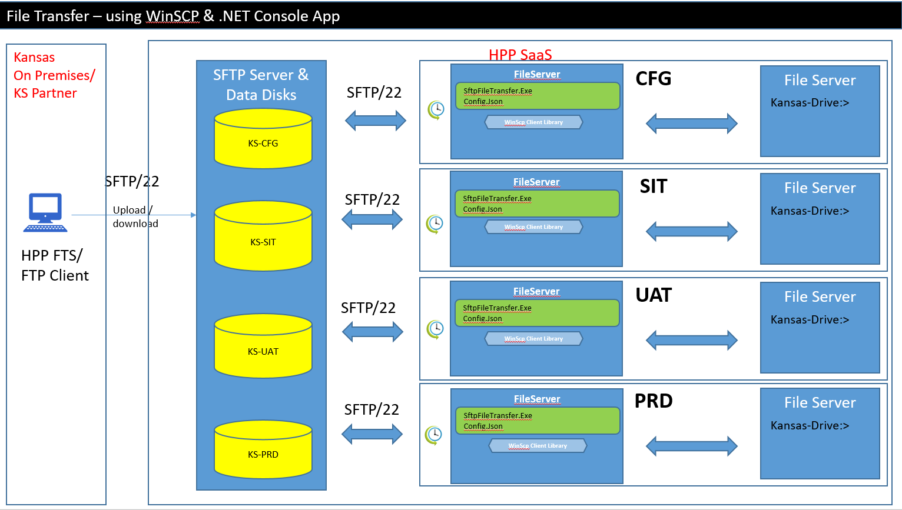

## **Config.Json**

**The configuration includes below 3 main objects.**

1. **SftpConfig :** To help configure SFTP server properties and credentials
2. **DownloadFromSftpConfig:** it’s an array of “Directory maps” to download files from sftp to fileserver.
3. **UploadToSftpConfig:** it’s an array of “Directory maps” to upload files from fileserver to sftp.

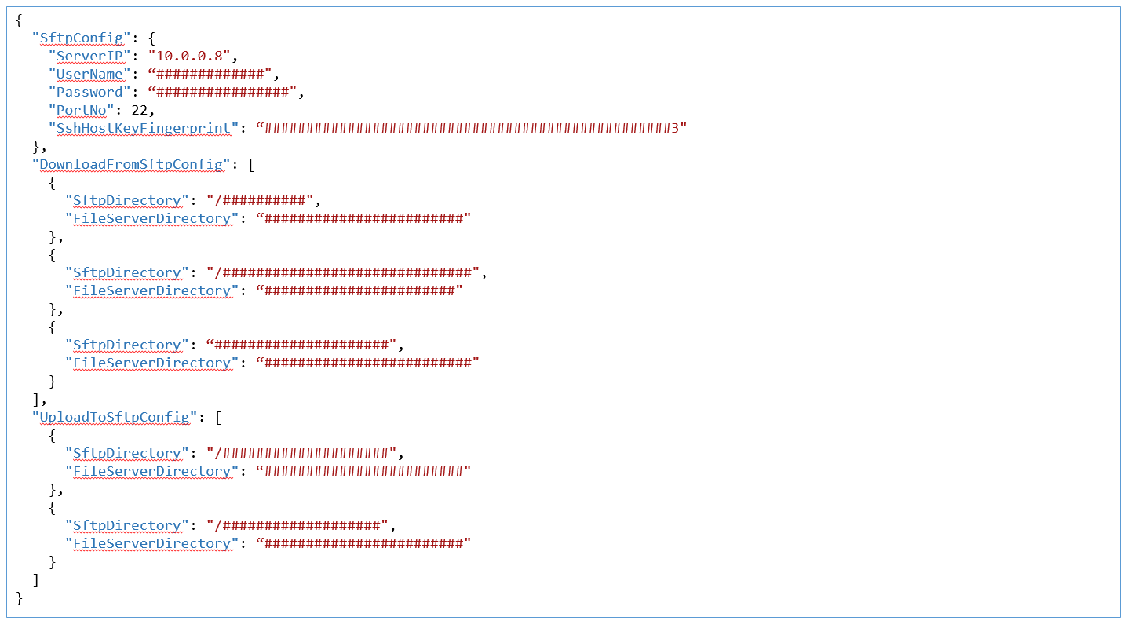

## **TFS Path Code Path:**

C:\ua3\Source\Utilities\Dev\SftpFileTransfer\SftpFileTransfer\

## **Build, Deploy and Configure:**

1. Open the project in Visual Studio.
2. Build the code in Release mode
3. Copy the Release artifacts in to a Target machine i.e, File Server on HPP SaaS Environments
4. Configure config.json files as per business requirement
5. Configure Log4Net configuration on app.config. Log files would be generated on the specified path below.

<file type="log4net.Util.PatternString" value="**C:\UA3\Logs\Tools\SftpFileTransfer\**" />

## **Schedule to run at regular interval:**

Since it’s a console application it shall be scheduled by task scheduler or autosys tools on windows.